|  |  |  |  |  |  |
| --- | --- | --- | --- | --- | --- |
| Date | 10-Dec-22 | | | Tester Name | Mohammad Yusuf |
| Environment | Penfax - Test | | | Login used |  |
| Operating System | Windows | Version: | Update: | | |
| Software Used | Edge | Version: | Update: | | |
| Not Applicable | Version: | Update: | | |
| Release version |  | | | | |
| Title | E7 Fund Transfers | | | | |
| Test Type | Regression | | | | |
| Test Scenario | E7.05 Rebalance the funds to a different percentage in the same funds they are in | | | | |
|  |  | | | | |
| Expected Results | 1. Asset rebalance should be processed and displayed under member’s account in Penfax and in Member PLANet. 2. PEPP Interfund Transfer Letter should be available. 3. Transcation should be listed on the Daily Valuation Report. | | | | |
| Pass/Fail | Pass | | | JIRA# | N/A |

Describe your steps with screenshots:

1. Search active PEPP member having current deposit allocation in more than 1 fund by SQL query.
2. Search for the stakeholder. Click on Stakeholder ID.

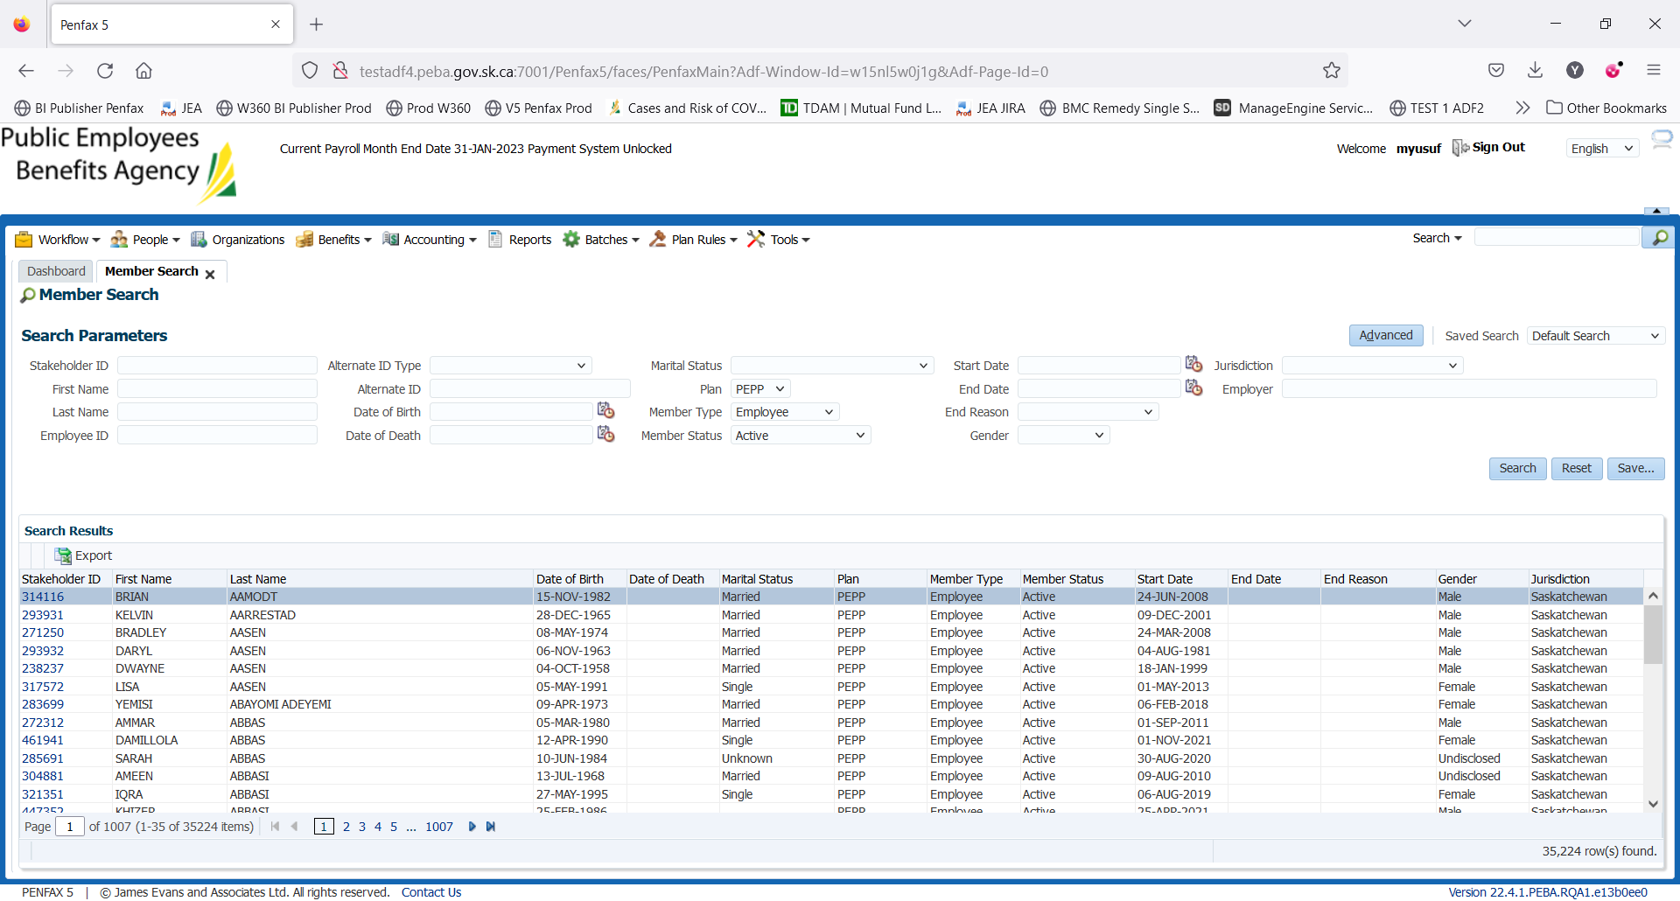

1. Click on Investments on the Navigation panel.

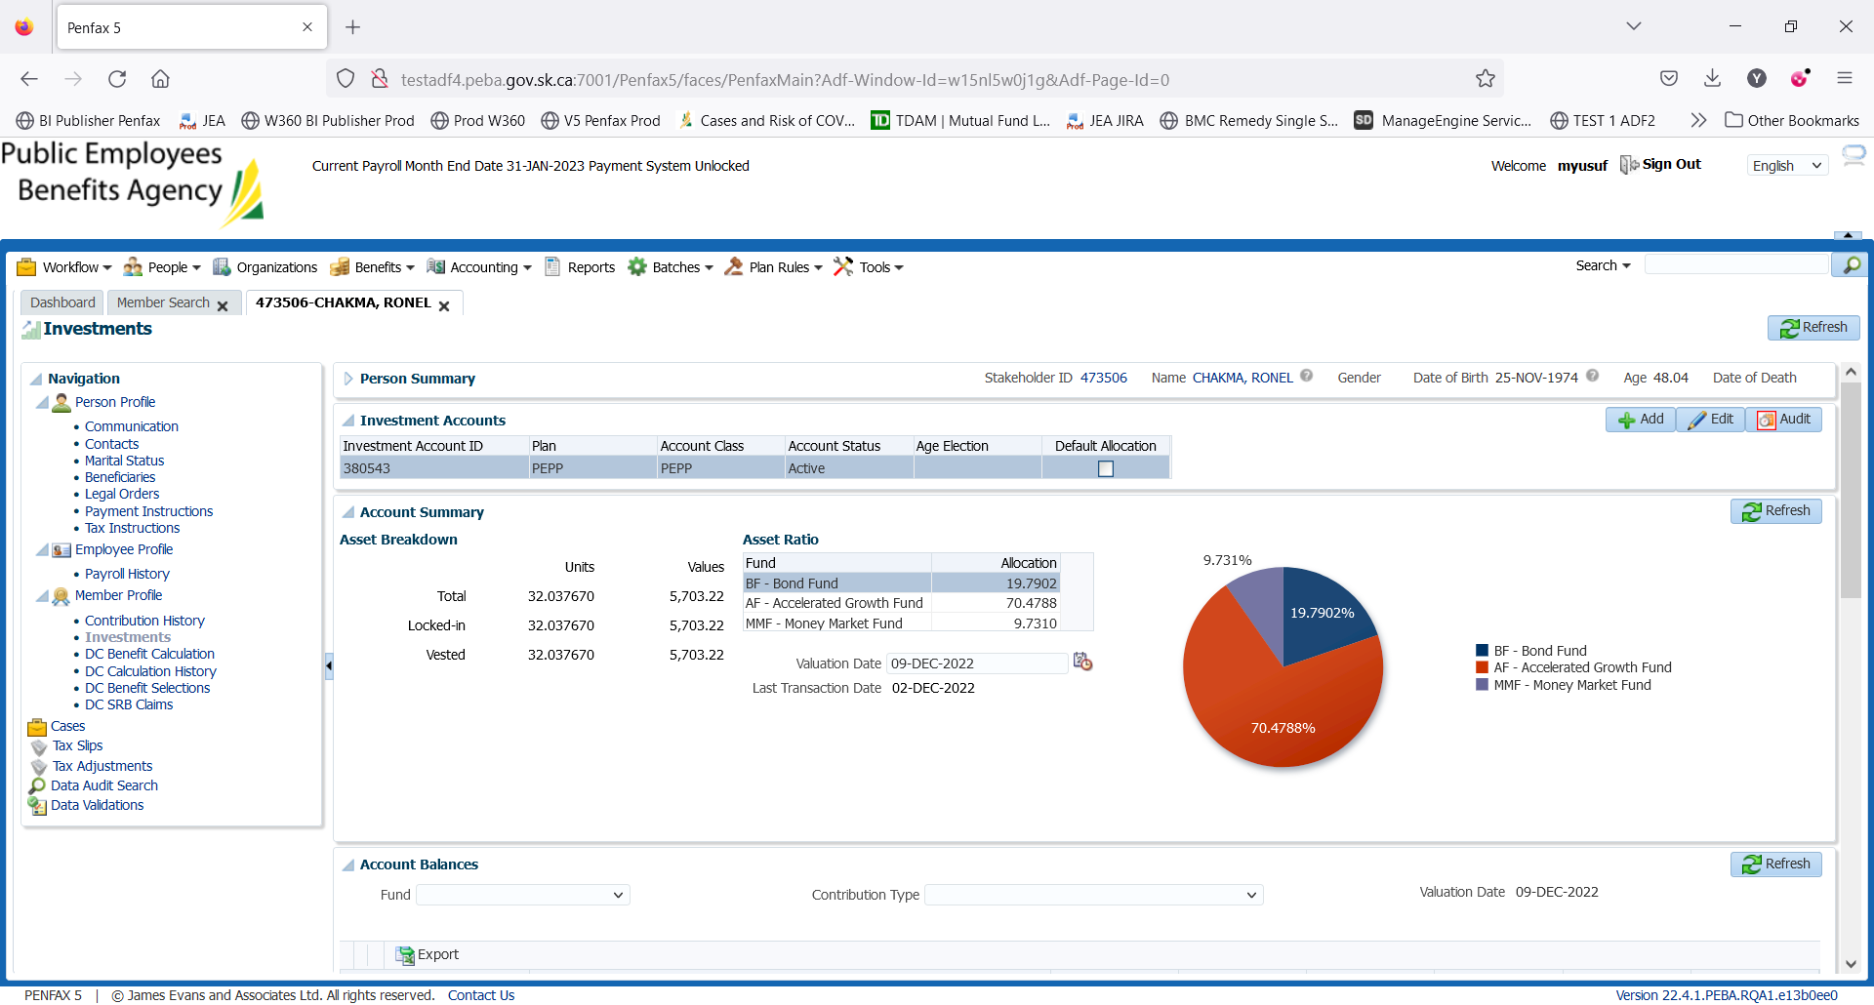

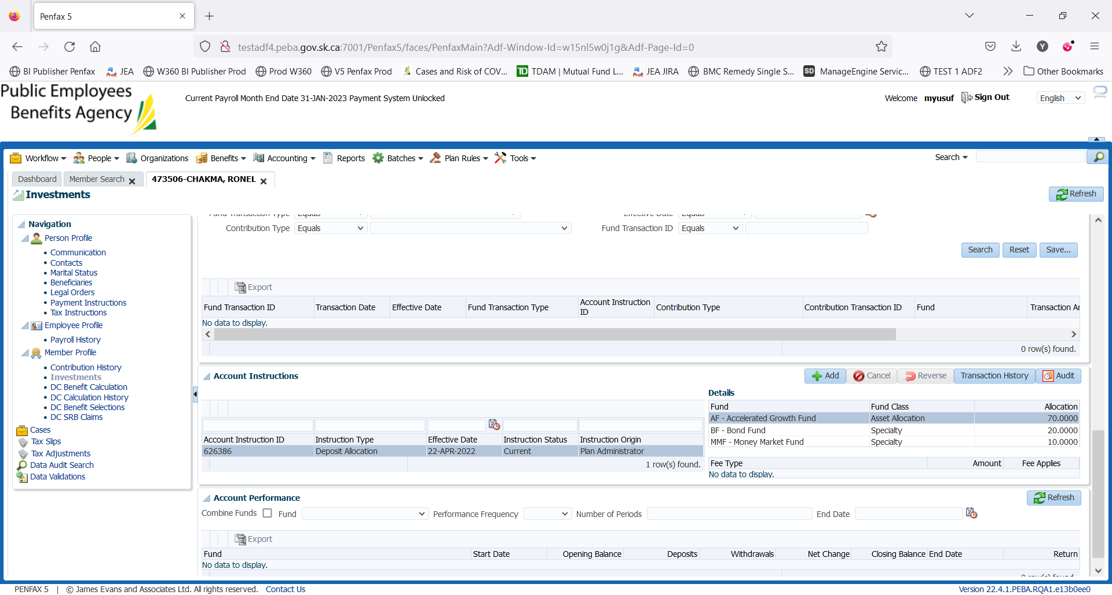

1. Scroll down and open up the Account Instructions Tab. Take note of what the current instructions are. Here, the current deposit allocation is 20% in BF, 70% in AF and 10% in MMF.

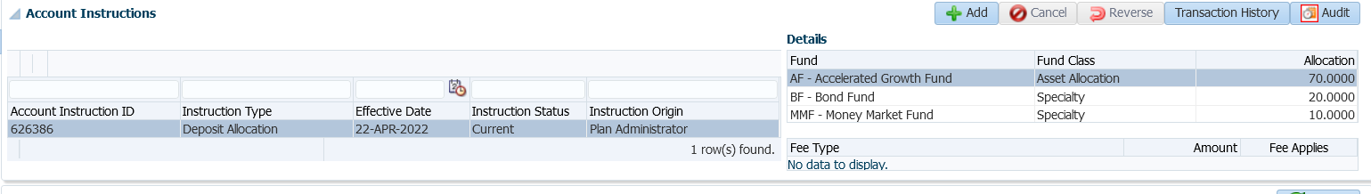

1. Click Add.

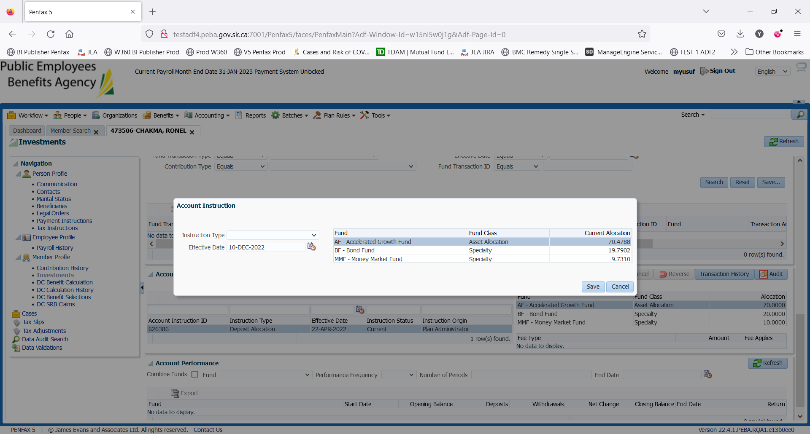

1. Under Instruction Type select Asset Rebalance.

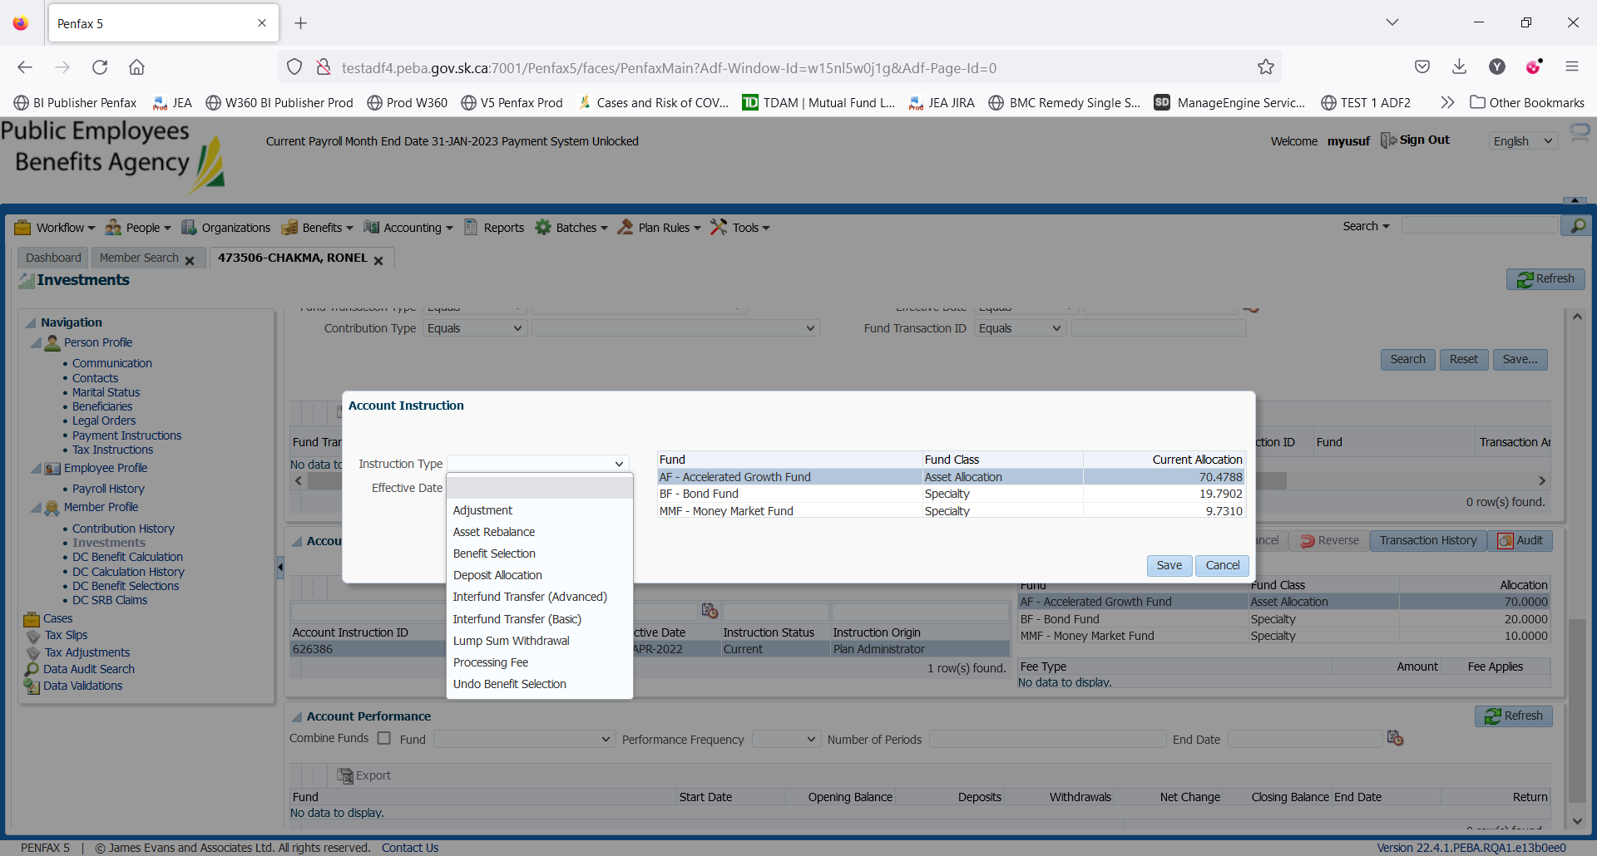

1. Click Add. Leave ‘Effective Date’ and ‘Fee Applies’ as they are. You can see where the current deposit allocation instruction on top right corner.

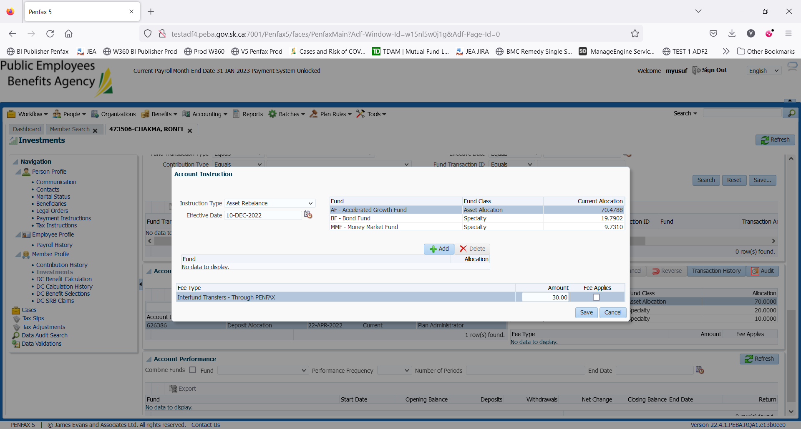

1. Adjust the percentage of allocation and click Save.

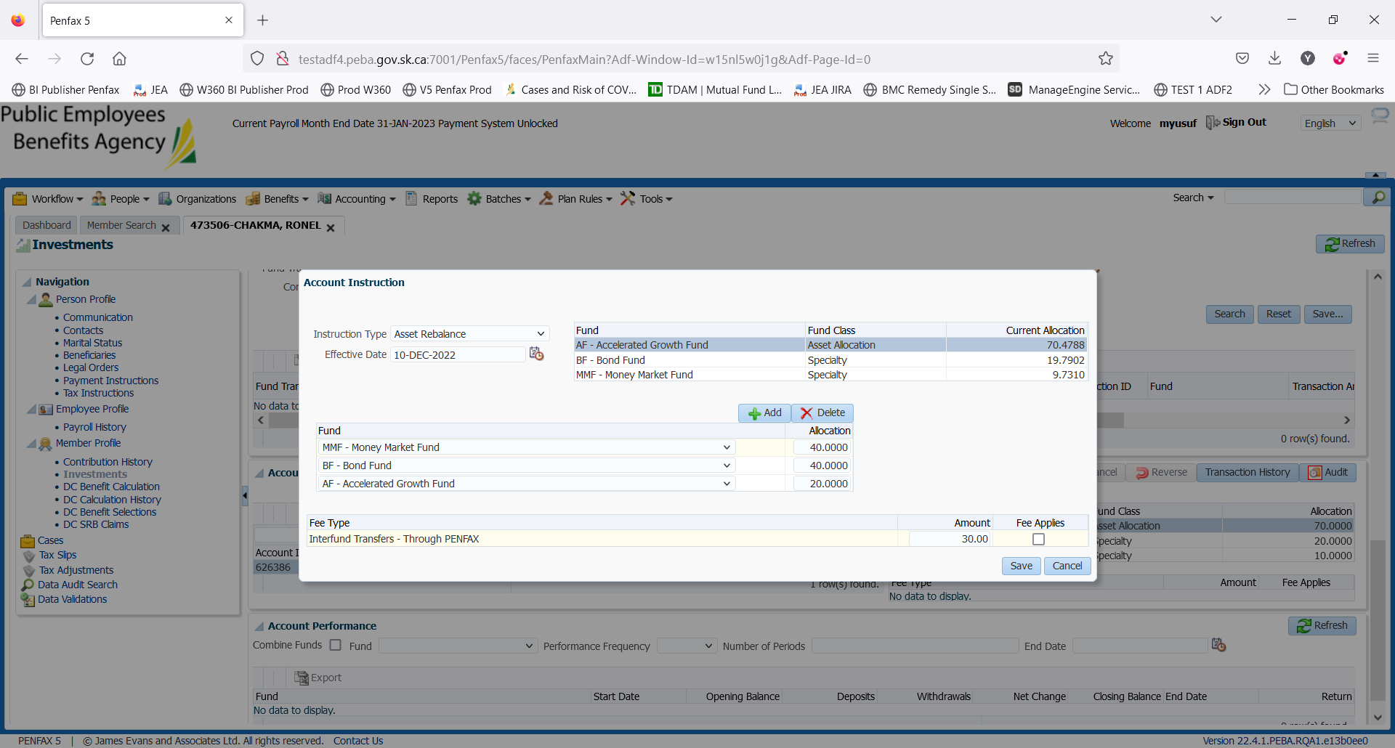

1. A new Instruction Type can be seen under Account Instruction with Pending Instruction Status.

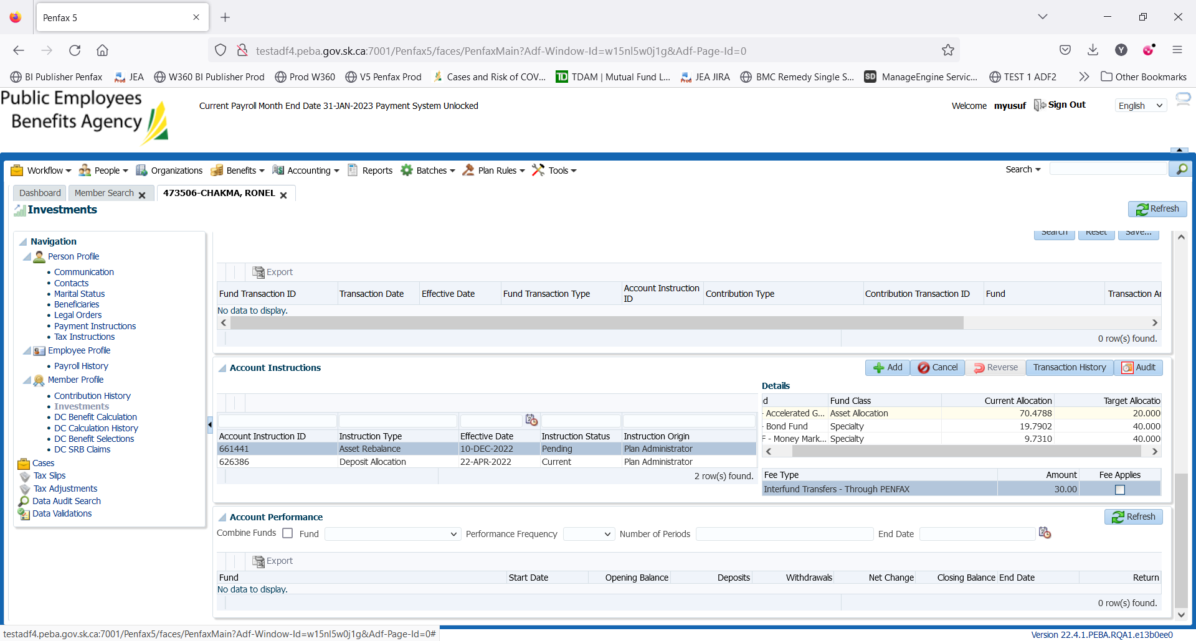

1. Member cannot see this pending account instruction in Member PLAnet (PENWEB) at this time.

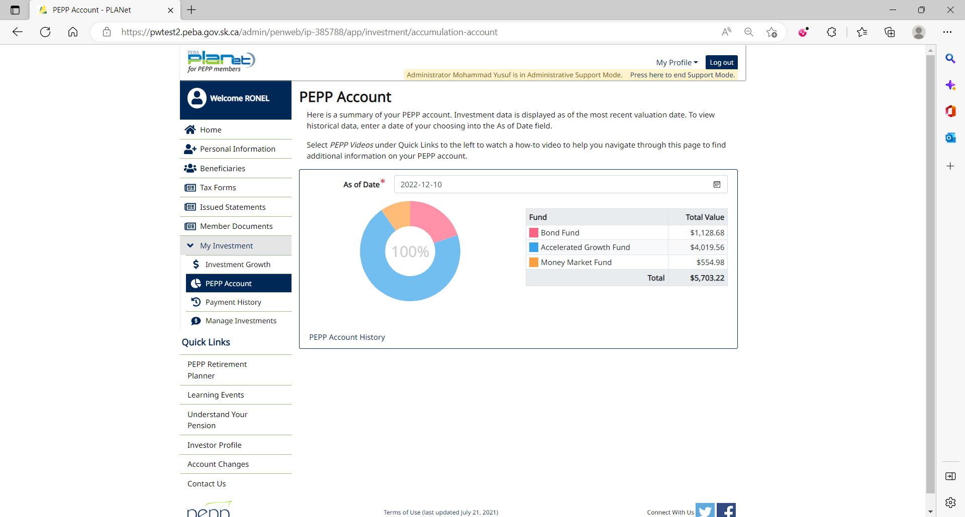

1. PIT batch was run overnight.
2. As per the Asset Rebalance processed yesterday (Dec 12, 2022), funds have been rebalanced.

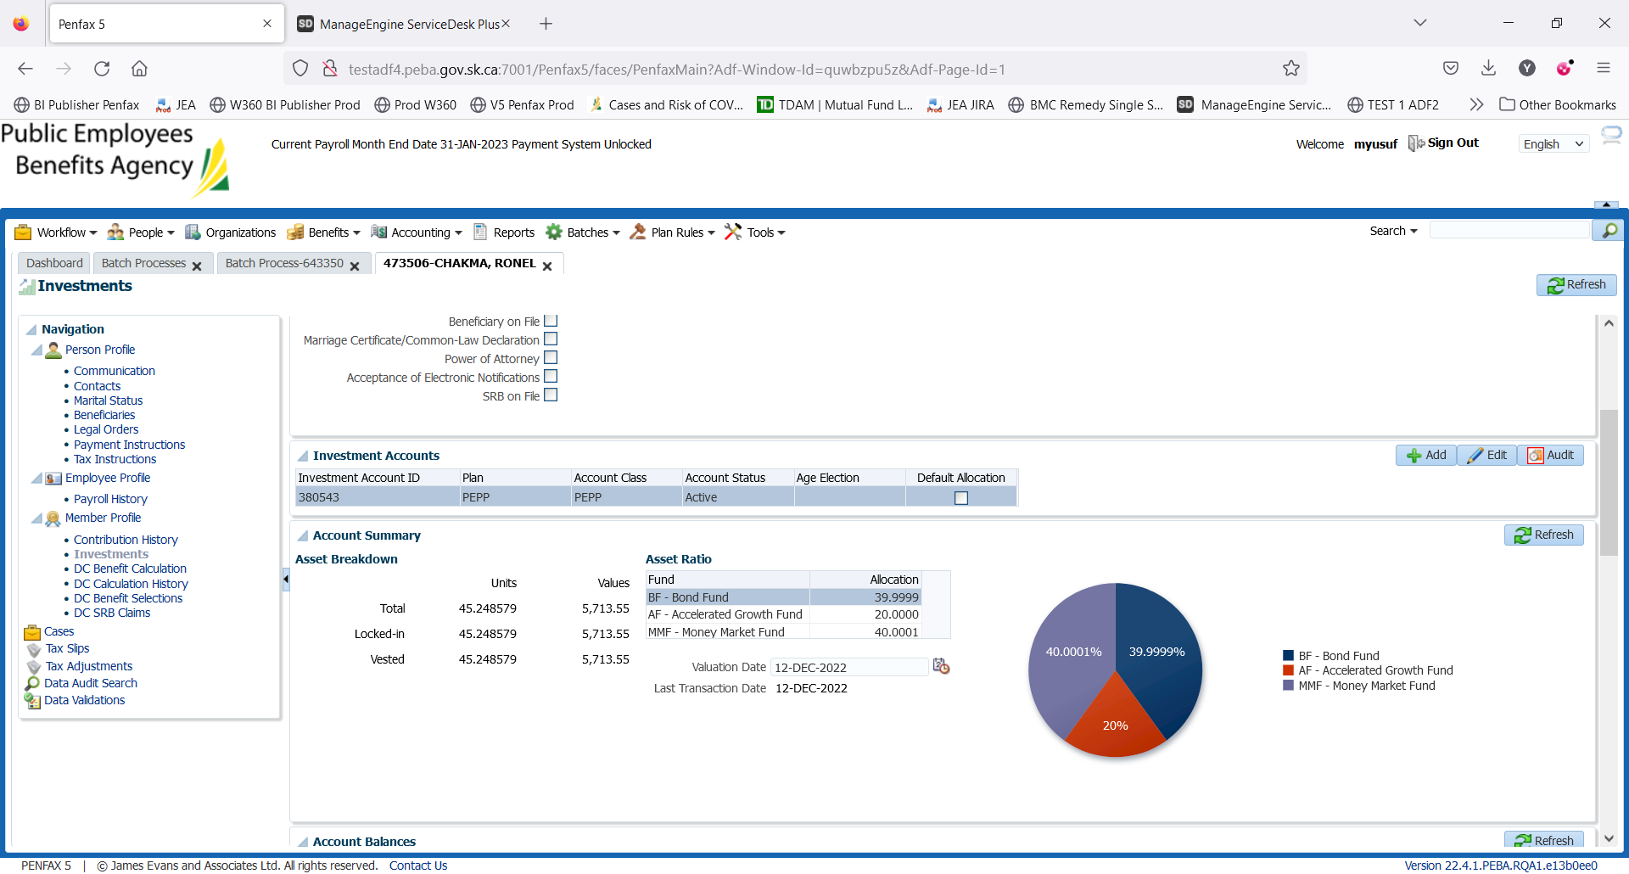

Transaction History of Interfund Transfer

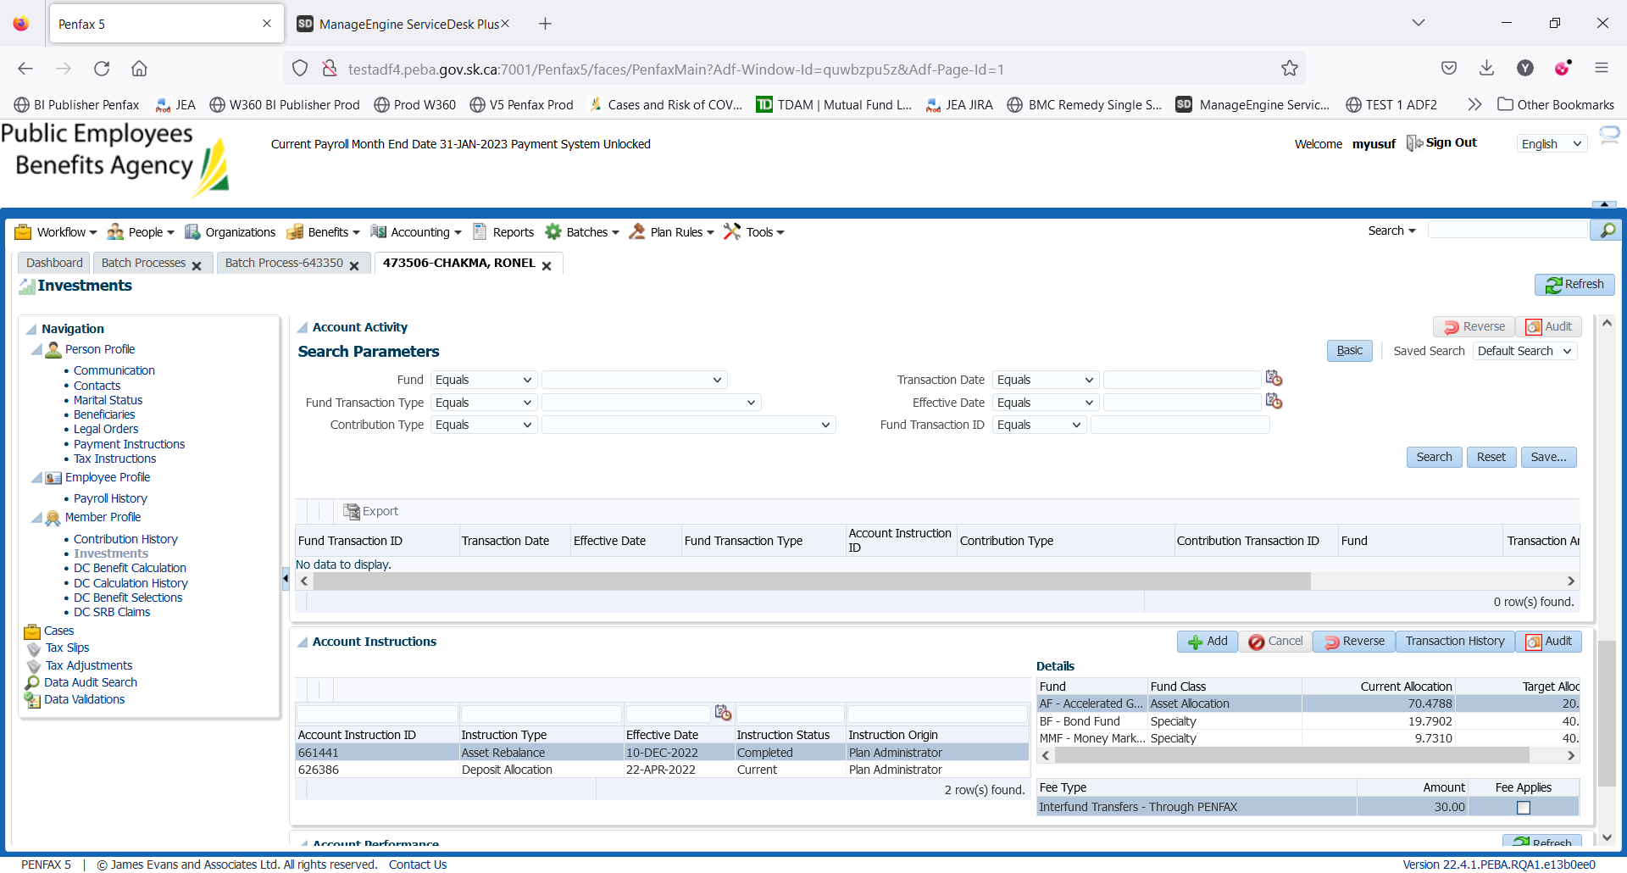

1. PEPP Interfund Transfer letter is available under Person Profile -> Communication -> Outbound Documents.

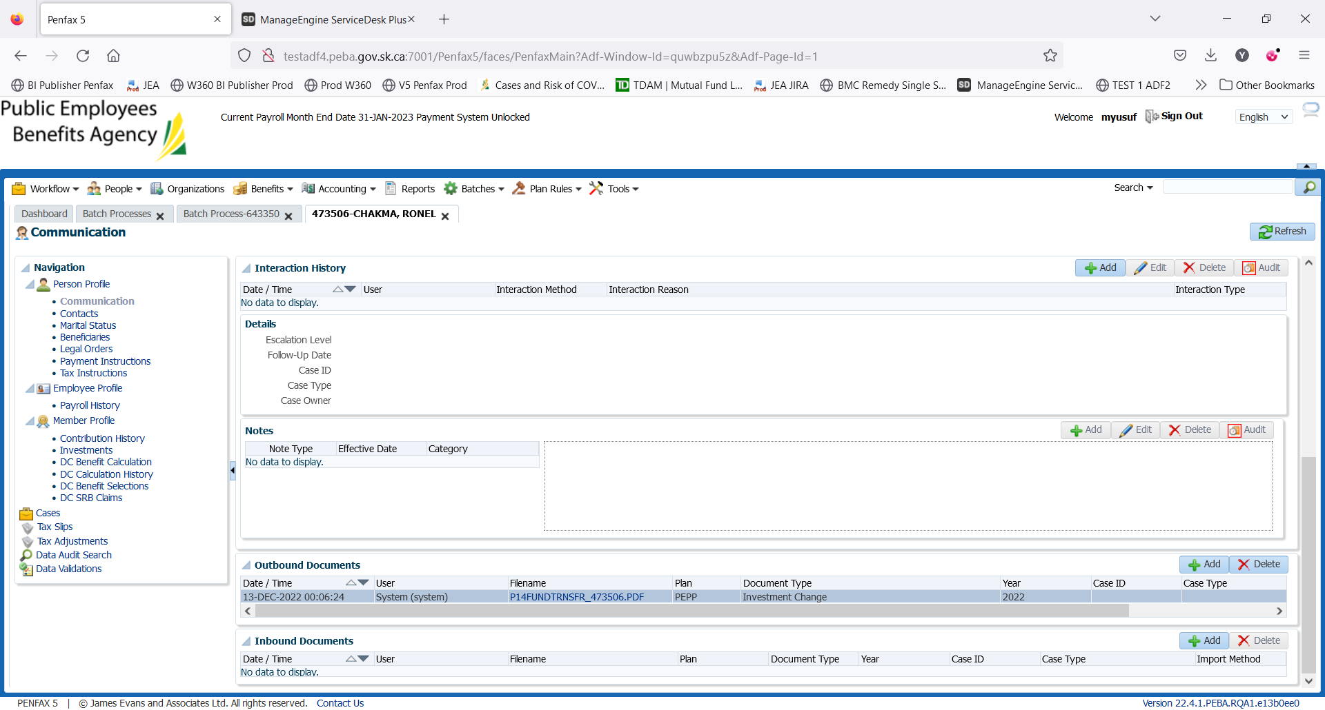

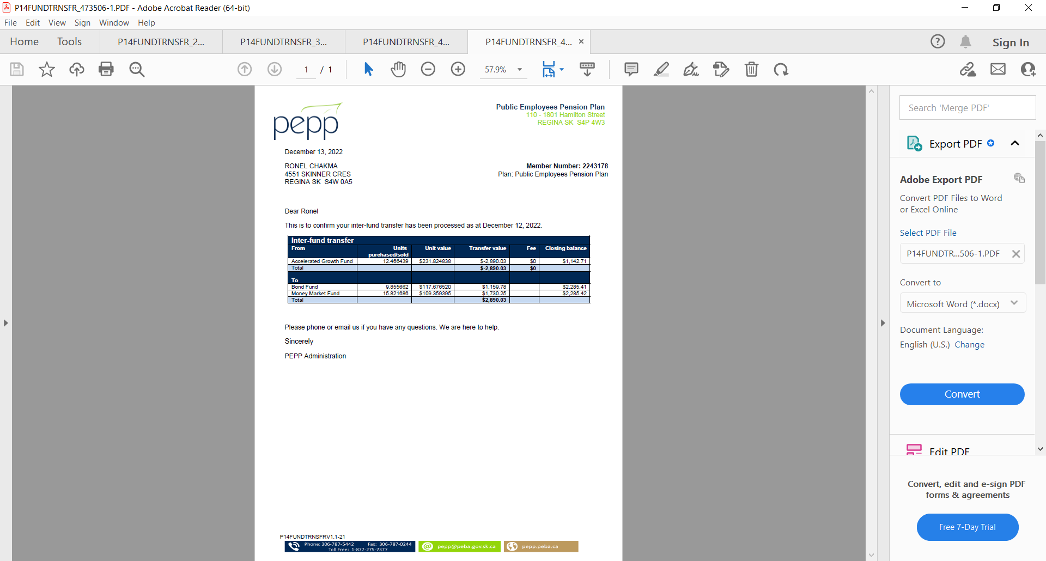

1. Check the Valuation Report. Go to Batches -> Batch Processes. Search with “PEPP Valuation Report” as Batch Process Type and open the very first record in the list (batch processed a day before).

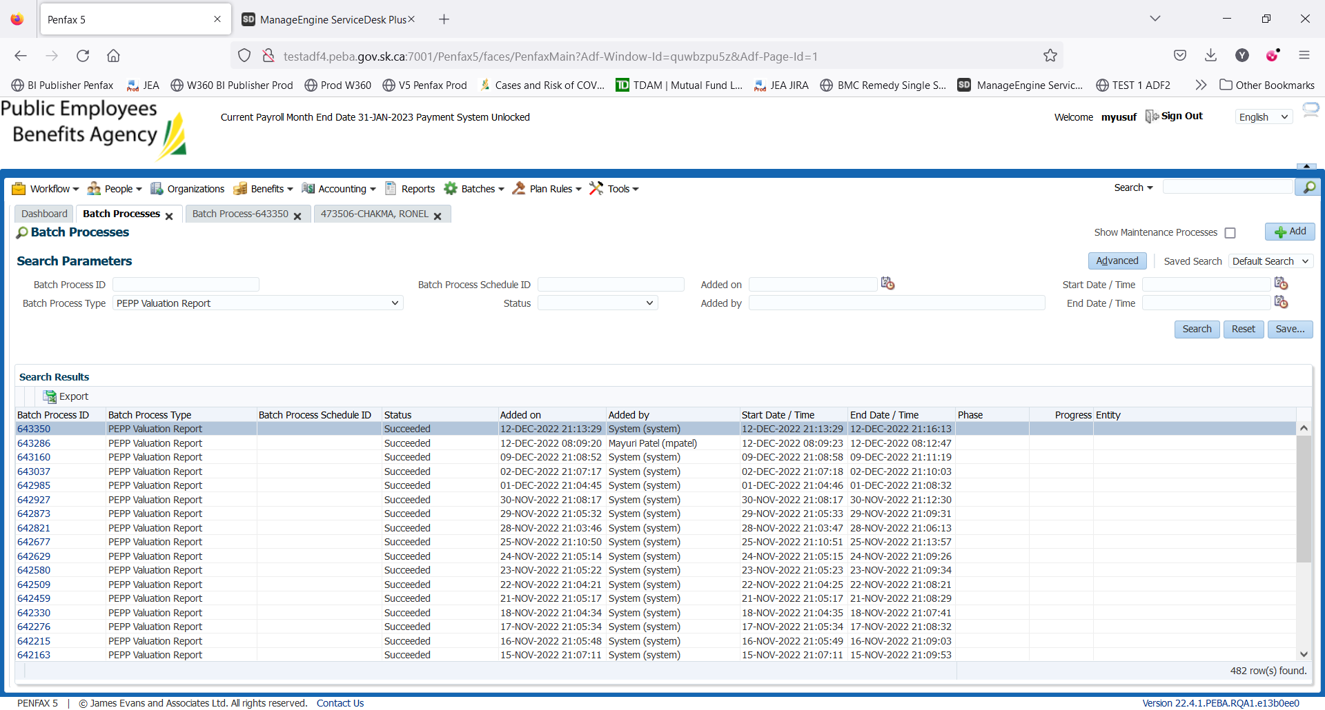

Go to Files tab and open PEPP valuation excel.

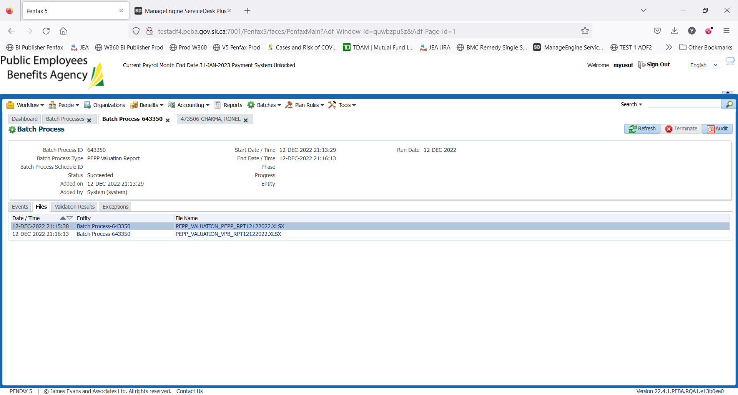

Section Four (Transfer In)

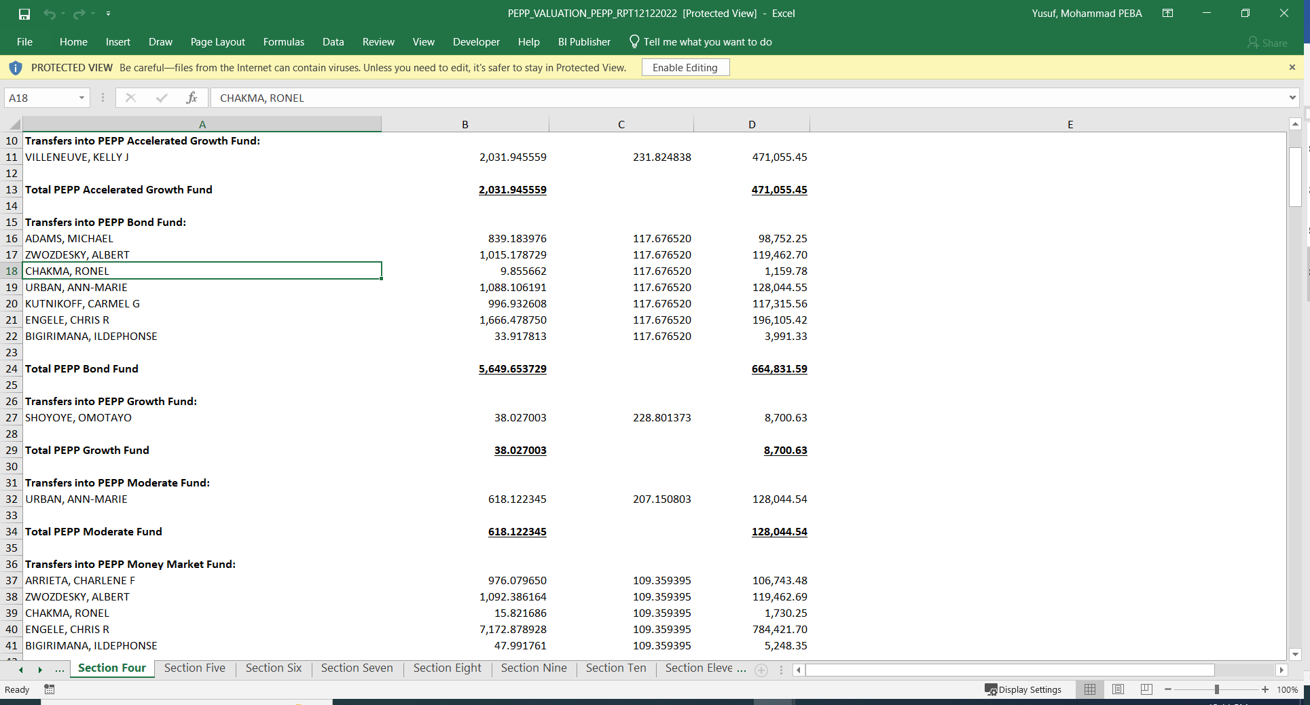

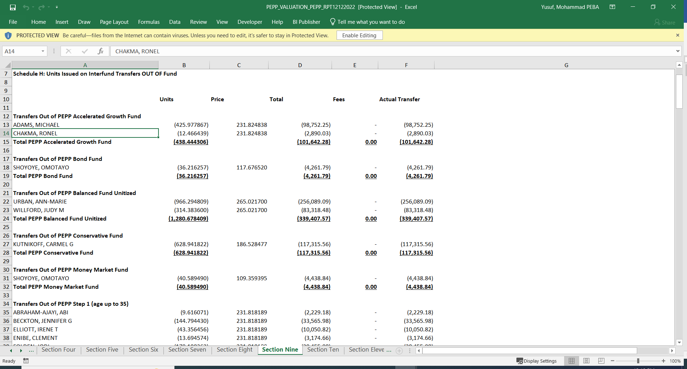

Section Nine (Transfer Out)

1. Member PLANet -> My Investment -> PEPP Account

